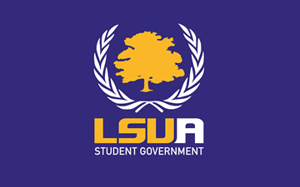

General Assembly Meeting Minutes
Spring Session
February 5th, 2019
Sentry Room

General Assembly Attendance:
Executive Board: President Brazzel, Vice President Walls, Executive Secretary Devon Deville, and Treasurer Barr
Senators: Rogers, Morris, and Adams

Advisor Attendance:
N/A

Guest Attendance:

- Call to Order
President Brazzel calls the meeting to order at 3:02 p.m.

- Executive Report
- Welcome
- Roll Call/Quorum
  - Roll call yields 6 of 11 voting members; Quorum is established.

- President’s Report
  - Chancellor- Chancellor Huang speaks about enrollment growth, connection between education and economy, and current work on infrastructure.
- Sanders enters and Morris exits.
  - DC Field Trip-President Brazzel notifies assembly about his trip to DC and how he is working on SG involvement outside of LSUA in political matters.
  - Gumbo Cookoff- President Brazzel notifies SG of gumbo cook-off. VP walls moves to fund $225 for drinks and snacks and sanders seconds. Motion passes with 6 ayes, 0 nays, and with 0 abstentions.
  - Meal Plans- President Brazzel discussed affordability of housing and meal plans, and on a possible bill. Will be looked into.
  - Textbooks- Secretary Deville is teaming up with advisor Malone to tackle textbook situation and need of book bank.
- Sanders leaves at 3:53, so quorum lost.

Minutes transcribed by Executive Secretary Devon Deville.

