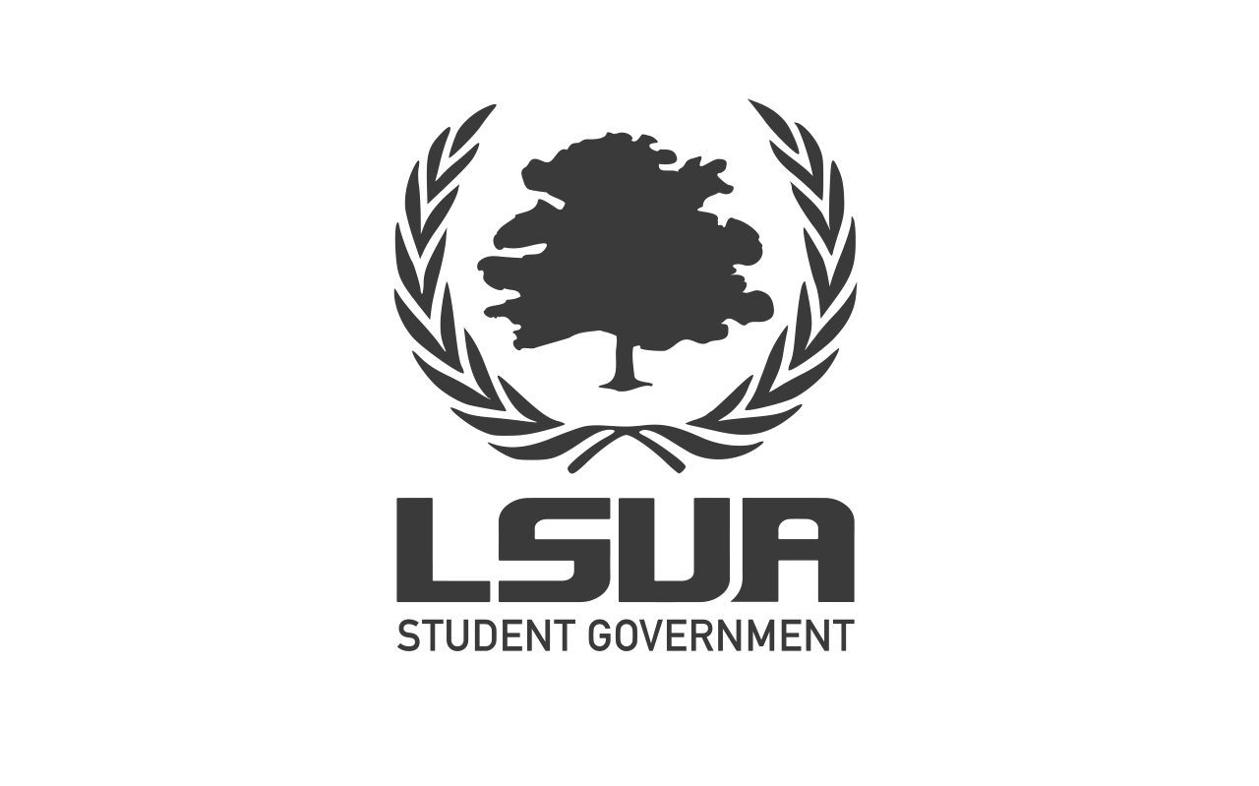
General Assembly Meeting Minutes
Spring Session
April 20, 2021
Bayou Roberts/Zoom
General Assembly Attendance:
Executive Board: President Aguilera, Vice President Barr, Treasurer Borhi, Secretary Gillam
Senators: Desmond, Kolby, Bree, Zoria, Adiannes, Mar’Krisseanna, Hailey, Manal, Travion, Terrie, Abbie, Tashia
Absent:
Advisor Attendance:
Haylee Malone
Guest Attendance:
Dr. Abbey Bain, Bryan Jackson (LSUA Student), Morgan Reed (LSUA student and bcm intern)
I. Call to Order
President Aguilera calls the meeting to order at 6:30 p.m.
II. Executive Report
A. Welcome
B. Roll Call/Quorum
- Roll call yields 15 of 15 voting members; Quorum is established.
C. President’s Report
- President Aguilera begins by reminding the members of Student Government about the Diversity and Inclusion Survey that is currently out.
- She then reminds us that Beautification Day at A is this saturday(April 24th) and she asks that we promote the event on social media. The chancellor will still be providing lunch but she also tells us to prepare for rain.
- We then discuss Finals week that is coming up and the idea of providing free coffee (a limited selection of drinks) from Starbucks for students during the week (from 10:00 am to 2:00 pm during the week). The suggested price for Student Government to go through with this idea is $1500. A vote happens: Senator Mar’Krisseanna motions to approve the amount and Senator Manal seconds the motion; 15 ayes and 0 noes.
- The BCM (Baptist Collegiate Ministries) then request $500 for t-shirts and give-away items during welcome week for the next semester. A vote happens: Senator Manal moves to approve this amount and Vice President Barr seconds the motion; 15 ayes and 0 noes.
D. Vice President’s Report
E. Committee Reports
III. Advisor Haylee Malone
- Advisor Malone begins by informing us next week’s Student Government meeting will be the last one (which will also be our end of the year party).
- On wednesday, April 27th, there will be a Health FAir on the quad (stress ball and other things will be given out).
- She also reminds us that elections are currently happening.
- Lastly, she asks that we all find her to sign a thank you card for facility services for helping us with the Crawfish Boil.
IV. Senator Manal
- Senator Manal is then given the floor representing the ISA, International Students Association.
- They would like to throw a graduation party for graduation International students and they are requesting $750 for food, drinks, gifts, and etc. After negotiation with the Student Government members, the request is brought down to $500. The a vot takes place: Vice President Barr moves to approve the amount and Senator Hailey seconds the motion; 15 ayes and 0 noes).
V. Vice Chancellor Abbey Bain
- Vice Chancellor Bain begins by reiterating about the upcoming Health Fair as well as providing new information: there will be 30 community partners there and she asks that we all attend and promote.
- She then mentions that the next Consent Workshop will take place next week on Wednesday, April 28th, at 2:00 pm.
- She closes by reminding us to “Mask Up,” as the mask mandate is currently still applied to our state. As Student Government, we should lead by example.
VI. Old Business
- Minutes approved: Senator Manal moves to approve last week's meeting minutes, and Senator Mar’Krisseanna seconds the motion. (15 ayes and 0 noes)
VII. New Business
VIII. Open Floor
IX. Adjournment- Meeting adjourned at 6:55 pm.
Minutes transcribed by Executive Secretary Kylan Gillam.

